STATE-OF-THE-ART VIDEO CONFERENCING TECHNOLOGIES AND PRACTICES. A REVIEW OF THE LITERATURE IN A NORWEGIAN CONTEXT.
Tord Talmo (⁰⁰⁰⁰⁻⁰⁰⁰²⁻²⁰⁰⁶⁻²⁰³⁶)¹, Jon Eirik Hennissen¹
¹The Norwegian University of Science and Technology (NORWAY)
Abstract
New and innovative approaches to teaching has arisen during the last decade, powered by access to new technology, societal changes and also the world wide pandemic during the years 2020-2022. In some aspects conservative ways of providing lectures has been replaced, especially considering video conferencing systems (VC). VC is a natural progression of technological advance in higher education (HE), but what does a video conference system contain, and how can one utilize it to achieve better academic performances?
This paper focuses on best practices for VC found in a Norwegian context. Through a targeted and structured literature review of recent articles produced in, about, and of Norwegian academics and researchers, the paper tries to identify preferred technologies, competencies needed, which factors create engagement, and which learning scenarios are most appreciated when using VC. The review identifies 12 papers, and the relevant findings are systemized and presented.
Based on this review, the paper tries to answer the research question:”Which technology and practices has been used in a Norwegian context in order to make VC function as a good learning environment”, and “What are the best practices for using Video Conferencing to activate students and achieve the defined learning objectives?”. Results show some diversity, but at the same time, some standard features are evident in most practices, such as using response technology to engage students.
Key words: Video Conference, literature review, Norway, pandemic, emergency remote teaching

INTRODUCTION
Digital skills are vital 21st century skills, and much appreciated in the educational sector. And it is also needed. Worldwide demand for higher education is expected to grow exponentially from 100 million students currently to 250+ million by 2025 [1]. This raises the question of how higher education institutions (HEIs) will be able to sustain and improve the quality of the learning experience in the face of continuing growth and diversity in the student population.
One of the possible solutions to meet the new demands for quality in the learning experience facing these new demographics and demands is to enhance the educational use of technologies and network resources available in the new era. Pedagogical approaches and methodologies for using Educational Technology (EdTech) has been accelerated and greatly improved, also due to the pandemic situation during the latter years. The COVID-19 pandemic forced many educational institutions around the globe to suspend face-to-face (f2f) classes and hastily replace them with online activities, affecting 94% of the world’s student population [2]. Few protocols, structures and research was ready for most teachers when doing the shift, and it seems apparent that the structure of teaching in physical classrooms did not translate directly into the digital realm.
HEIs are facing considerable challenges too big to be dealt with by one country acting alone: the economic crisis; unemployment, especially for young people; changing demographics; the emergence of new competitors and new technologies and modes of working [3]. New student groups want education that is relative, timely, available on-demand, and fits a specific need. For these reasons and more, we begin to see a shift also in HEIs from traditional colleges to more interactive, technology inspired and internationally oriented institutions. This also includes new and improved ways of performing Video Conferences (VC).
In order to succeed with implementing new EdTech in learning environments, one needs to define the pedagogical approach, and especially answer the question why one should use EdTech. Maybe the most important question is how to engage students and create lectures in an online environment where the students are active participants.
There has been valid attempts to investigate especially the impact the pandemic had on online learning and VC, and also how politics and practices changed during the pandemic, often referred to as “Emergency Remote Education” (ERE) [4]. The research has not concluded in any way, but has differed between a wide range of considerations, like the negative side of online learning compared to in-person learning [5], to discussing to what degree VC and online learning might be a catalyst for change and improvement [2] or just pointing at inequalities that are heightened when introducing EdTech in learning environments due to differences in access to high-end solutions both in institutions and among users. The global situation is unclear, and the research does not show any clear paths on how to tackle the problems occurring from the shift into more online lectures.
From a Norwegian perspective the same tendencies as globally has been seen. In Norway much of the strategy being implemented is made from government, even if there are a lot of trust in the single institutions to actually perform the actions being proposed. In a previous article, Talmo has pointed out that the Ministry of Education and Research in Norway are highly concerned about digitalization, and the idea of giving students access to modern, high-tech and innovative learning solutions, aided by technology [6]. In “Digitaliseringsstrategi for universitets- og høyskolesektoren” [7] (Strategy for digitalization of Higher Education in Norway) it is listed aims for digitalization of HE in Norway, and some means to achieve these are mentioned. There is a great focus on infrastructure and digital tools in the strategy, as well as an idea of raising the digital competency amongst staff and students. As an example, teachers should be better equipped to cope with new methods of teaching and to adapt to new demands for digital skills [6]. A strategic approach like this helps, and it is interesting to see how infrastructure is emphasized, even if there are no direct mentioning’s of online learning environments or VC.
The digitalization strategy needs to consider the interplay between the pedagogical/methodological approach and the use of technology in various learning scenarios and related spaces. A good representation of the correlation between these factors can be illustrated by the PST-framework developed by Radcliffe [8]. Easy and scalable, PST shows how the interaction and cyclical processes in the framework as iterative processes that collect experiences and evaluations during the whole life cycle of a learning environment/space.
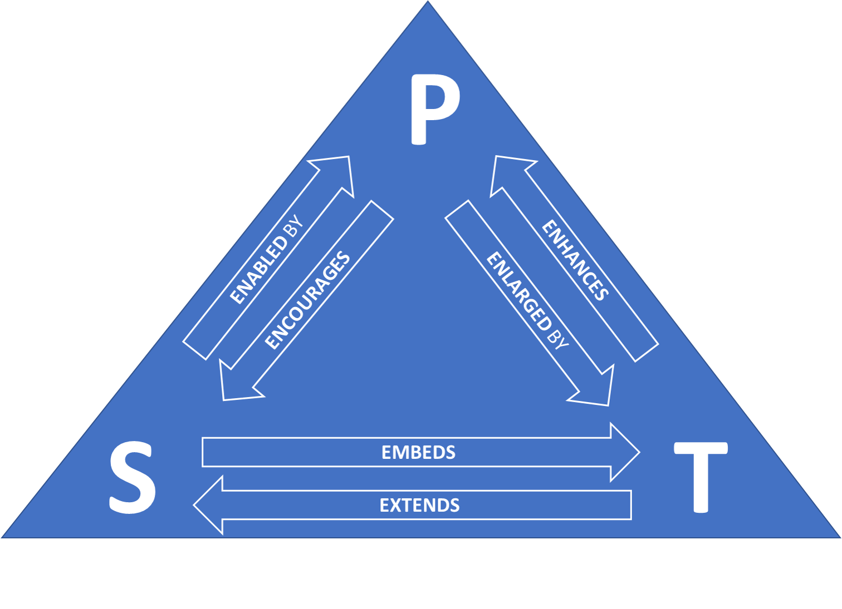
Figure 1. Original PST-framework
However, the space in the PST-framework might be defined as a physical space (F2F), a hybrid space and an online space. The challenges appear when moving between these spaces and adapting the pedagogy, related resources and activities, based on the mediating techniques/technology. In a modified PST framework [9] we find Pedagogy as the main starting point which is mediated through educational technologies to provide the continuum from physical over the hybrid to the online learning space [10, 11].
Understanding the shift from one learning space to another, and the processes included demands a better view on both technology used, but also on approaches and best practices applied in a specific context. Thus, a systematic literature review on Norwegian contexts will provide insight into how to design a Educational Video Conference system that enhances learning for the involved participants. The research questions for this article is therefore articulated as: ”Which technology and practices has been used in a Norwegian context in order to make VC function as a good learning environment”, and “What are the best practices for using Video Conferencing to activate students and achieve the defined learning objectives?”.

Methodology
In this systematic literature review, on Norwegian studies done during the Covid19-pandemic, it is applied the Preferred Reporting Items for Systematic Reviews and Meta-Analyses (PRISMA) flow diagram in a moderated form [12]. PRISMA includes four phases: identification, screening, eligibility, and included articles. In figure 3 the process is illustrated in the study done at Norwegian University of Science and Technology (NTNU).
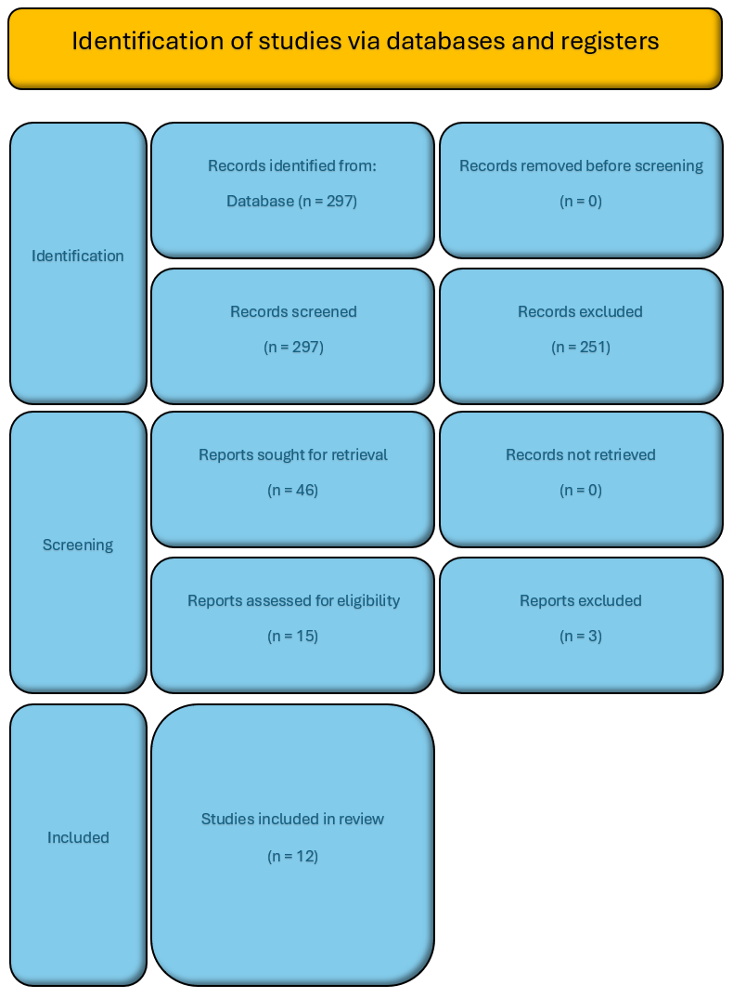
Figure 2. Flow-diagram of literature review NTNU

We started off with a search in Web of Science. The inquiry was conducted with the key string TS=((Education*) AND ("Video Conference*" OR “virtual conference” OR hybrid” OR “Online conference*”) AND (Engagement OR Interaction” OR communication OR discussion OR "Learning Experience Design" OR “learning environment” OR flipped)). Additionally we restricted the search to the years 2017-2023, English language and articles only. As a result we ended up with 1245 relevant articles.
It was decided this was to many hits, and we ran a new search restricting even more, and directed the search towards Norwegian conditions. We also wanted to find best practices from Universities more than general education, but seeing in Norway there are many projects and studies being done from Universities on general educational conditions, we needed to still include “Education” in the search string. The second search therefore was conducted like: TS=((Education* OR university) AND ("Video Conference*" OR “virtual conference” OR hybrid OR Online) AND (Norway OR Norwegian)). Additionally restricted to 2017-2023.
The second search included 297 articles published (date 02.02.2023).
This selection of 297 was screened by a researcher reading the abstracts. To select full articles to analyse, it was included keywords to look for and categorize in (see table 1), and some exclusion criteria: 1) If not empirical, 2) not focusing on meetings, 3) PhD and Master dissertation, 4) conference acts (i.e, how to conduct a conference) and 5) no MOOCs.
When doing the analysis, the focus was on categorizing and synthesise some similarities between the contents of the articles. Beforehand a set of keywords, displayed in table 1, was defined. Each of the included articles was read and notes taken concerning educational level, types of video conferencing equipment, different online applications used, to what extent the article is concerned about portability, how engagement was created and/or focused in the study and the type of learning design applied. This aided the analysis being done by the researchers, and thus created results shown in table 2 later.
Table 1. Keywords used when screening articles. Examples provided in columns
Education | Video Conferencing | Online Application | Portable | Engagement | Learning Experience Design
School | Virtual conference | Software | Mobile | Interaction | Learning environment
Learning | Hybrid | Platform | Remote | Communication | Flipped (classroom)
University | Online conference | System |  | Discussion
Teaching | Zoom, Teams, Google, Skype, Meet/Hangout, Adobe Connect, WebEx
After the analysis, another three articles were discarded due to 1) lack of Norwegian context, 2) similar article as another with a different heading and 3) actually describing a MOOC-course even if not intended. Thus, we were left with 12 articles to analyse and summarise.

Analysis and synthesis
The reviewed papers on video-conferencing technology-mediated teaching are analysed and summarized with the intention of identifying key features within the six categories defined as essential in Table 1 (Education, Video Conference, Online App, Portable or not, Engagement, and Learning Experience Design). In the following a short review of each article will be presented.

Article review

“Using Padlet to Enable Online Collaborative Mediation and Scaffolding in a Statistics Course”. [13]
A study which emphasises Computer-supported Collaborative learning (CSCL) for large classroom. The study aims at explaining to what degree the usage of the response technology Padlet enhances interaction and active learning in large classrooms at HEI. The results are based on in-depth interviews and analysis, as well as online surveys. Main findings are that the usage of Padlet increases the students learning and engages them in discussion when used properly and over time. It also states that to be successful one needs an active lecturer beyond contact hours.

“Student Perspectives on the Digital Learning Experience During COVID-19 Lockdown”. [14]
A qualitative study that analyses 200 student responses in an ICT-course at HE-level. Coining the phrase ERT (Emergency Remote Teaching) as a rapid change from physical to online teaching that sets a different context than planned online education. In the study both teachers and students are used to Technology (ICT-course), thus the emphasis is on Tech-Ped-interaction. Main challenges connected to students lack of structure in online settings and ways of creating interaction and engagement when lecturing. Especially interesting to see the discussions on monological lectures and the poor effects of break out-rooms applied.

“Students' Experiences with Online Teaching and Learning in Norway: A Qualitative Study into Nutrition Education One Year after the COVID-19 Lockdown”. [15]
An article reporting on online teaching during the pandemic (one year into it). In a course at Oslo Met in Public health nutrition they included ten informants that had been attending studies both before and during the lockdown. They performed qualitative interviews and did a thematic analysis. Four main themes emerged; Increased participation, Reduced learning quality, Motivation and social contact and Important factors in Digital Teaching. This led to recommendations for the post-pandemic teaching.

“From technology to community: the role of artefacts in teaching and learning during and beyond pandemic times”. [16]
A study reporting on changed practices amongst teaching staff at HE in Norway. Sixteen informants (pedagogical staff) were interviewed. The data collected focused on pedagogical practices, not technological artefacts. Main aim of the study was to identify differences in artefacts being implemented, and categorize these in primary, secondary and tertiary artefacts [17]. A clear result is that the change from f2f to online/hybrid affects the whole university system, and that it thus emerges a need for a broader community, both peers, but also management (to structure, train and allocate time).

“Online interactive face-to-face learning in mathematics in engineering education”. [18]
The article presents a variety to the traditional online streaming of mathematical lectures by introducing a transparent whiteboard. The method is called TeachUs, and allows for preserving a sense of traditional lectures, including body language and eyecontact with the students, and still display the equations, graphs and statistics being shown. Several courses and students have been involved in the evaluation of the method, and there is almost only positive feedback. TeachUs is supposed to be built as full software in the future, and maybe be integrated into existing VC system.

“Teachers' agency and online education in times of crisis”. [19]
A study aiming at examining the nature of teachers activities in the first weeks after the pandemic lockdown in March 2020. The study gathered informants through a bottom-up initiative on Facebook. This means that the article mentions and briefly discusses a large amount of online teaching methods. The aim is to categorize the teachers agency, in order to trigger a response for heigthening academic professionals needs for either digital competency and/or pedagogical practices. The article is barely within the scope of this study, but is still included due to mentionings of several useful softwares and tools.

“An Abrupt Transition to Digital Teaching-Norwegian Medical Students and Their Experiences of Learning Output during the Initial Phase of the COVID-19 Lockdown”. [20]
A study aiming at investigating students experiences with learning during the first semester of lockdown due to COVID19. 230 students answered the questionnaire. Mainly the students expressed positive attitudes towards the theoretical lectures but were dissatisfied with the practical and clinical studies.

“A transition to online teaching and learning of mathematics in Norwegian higher education institutions: the perspectives of lecturers and students”. [21]
A study collecting data from 10 lecturers and 6 students enrolled in a mathematical course at University. The main aim of the study is to investigate how the transition from physical to online classes has affected the learning of mathematics. Interviews gathered through networks, thus making the chosen LMS’ and online apps more diverse. The study shows some features, both technological and pedagogically, that enhances the learning experience for students when doing online classes. A special focus is given to online apps available for mathematical lecturing and knowledge.

”Switching to Fully Online Teaching and Learning of Mathematics: The Case of Norwegian Mathematics Lecturers and University Students During the Covid-19 Pandemic”. [22]
This article is a follow -up study of the previous article 3.1.8. This study has used the qualitative results from the previous study to design an online survey with more respondents. The main aim of the study is the increased awareness amongst mathematical teachers on challenges connected to the transition to an online learning environment. Again, the survey results stretch over several different learning institutions, and it is therefore difficult to synthesize the results in a generic way. Still, some interesting findings are mentioned, thus making the survey interesting for how to design for academic effect in VC.

“Hybrid Learning Spaces with Spatial Audio”. [23]
An article reporting on the build of a portal, in which technology enhances the mediation of sound, acoustics and spatial noise in an online environment. The study and build has been done in two remote universities, in the subject of music. Keeping functions and hardware separate for both maintenance/troubleshooting issues, and for better pedagogical approach. The article is mainly focused on hardware, but introduces everything using the PST-framework, emphasizing the pedagogical effects to be obtained from the portal.

“The effect of changing from campus-based to digital teaching on student attendance: A case study of Norwegian business students”. [24]
An interesting study aiming at measuring attendance rate, and eventual changes when moving from the physical classroom to the digital during the COVID19-pandemic. Results show the attendance is higher in the fully digital classes, and that students drop-out earlier in the physical classes. The article offers few insights, at least considering the pedagogical and technological approach, to the results described.

“Norwegian Teachers' Experiences with Distance Teaching and Online Schooling During the COVID-19 Pandemic”. [25]
This study investigates the teachers’ reactions and experiences to the shift to digital learning environments after the COVID19 outbreak. A total of 120 teacher in one municipality has answered an online survey with open-ended questions, thematically analyzed. Not too much on tools and pedagogy applied, and the results show that increased digital competencies, good management and a structured day are key to success in the transition

Discussion
Findings from the review is summarized in table 2.
Table 2. Summary of findings in reviewed articles
Category | Description | Summary
Education | Mainly Educational level, but also logged different subjects and learning environments. Mostly interesting in order to figure out where the innovation and new functionalities were developed and tested. | There are a nine of the articles focused on HE. 3 articles focus on staff members and their development, whilst two articles are focused on secondary education. There is an overweight of profession-oriented educations, like nutrition, nursing and IT. It is also worth mentioning that five of the articles are concerned with online teaching, 2 with hybrid, and there are few mentioning’s of implementing Ed.Tech in physical lectures.
Video Conference | In this category it is focused on types of video conferencing equipment and systems are being used. The findings are focused on types of software discussed, researched, used or mentioned briefly. | In total a software for video conferencing is mentioned 34 times in the materials. Zoom is most frequent (n=8), followed by Microsoft Teams (n=5), Facebook/Messenger (n=3 and Canvas, Adobe Connect, Google Classroom (n=2). BlackBoard Collaborate is mentioned once, and there are some specially built software being reported on in single articles. Additionally, it is interesting to see that different storage areas, i.e. LMSs and Google Drive, are frequently mentioned as important.
Online App | When using video conferencing there are several software applications that might aid the teaching and learning. These may be both online applications or apps to install on your computer/padlet/phone. In this category we have also included programs used to present and/or run sessions in the lecture. | In total apps like these are mentioned 25 times in the material. Most of the apps are mentioned once, this includes WeWork, Matehematical text (beamer), Piazza, Maple, YouTube, Jupyter Notebook, Geogebra, learning path functionality, virtual bulletin board, Slack and Discord. Polling systems, like Mentimeter, Padlet and Kahoot, are mentioned 4 times, and PowerPoint 3 times. The mathematical apps Matlab and STACK are mentioned two times each. There are also some articles discussing digital accessories (n=3) like digital pen, ink, whiteboard, screen sharing and shared document.
Portable? | In this category it is foreseen that the video conference equipment being used is either portable or stationary. | 4 articles discusses portable systems.  3 articles discusses stationary equipment.
Engagement | This category is concerned about how the articles have tried to promote engagement in the students group. Mainly it is interesting which tools have been used, but also the way they have been used. | Most articles mention chat as a way of getting students engaged (n=5). Break-out rooms and video/recordings are mentioned 4 times each. Three times it is stated that that leaving the camera on is essential, and then there are several categories that are mentioned 2 times: Response technology, anonymity for students, small tasks, coffee breaks, collaboration, common writing surface and discussion forums. One mentioning for push notifications, pictures, music, structured teaching plan, virtual books, role playing, board games, podcasts, online support centre, differentiating content (symbolic, interactive, graphical), and academic poster.
Learning Experience Design | This category is mainly concerned about the type of pedagogy applied when using video conferencing. It also includes findings on ways of delivering the content in a lecture. The category also includes some other factors that influences the learning experience for the students. | Considering the pedagogy there are different socio-cultural pedagogical approaches mentioned: Self-regulated learning (n=1), student-active learning (n=3), collaborative learning (n=1), Socio-cultural learning (n=1), embodied cognitive theory (n=2).  When delivering the lecture, it seems as the preferred method is smaller groups: Workshop (n=3), lectures (n=3), hybrid mood (n=1), Projects (n=1), flipped learning (n=3), seminars (n=4), video recording (n=3), home exams (n=1), laboratory work (n=1), streaming (n=3), and supervision (n=1).  Some articles also discuss guidelines for pedagogical support (n=1) and the time of day for lectures (n=1)
Maybe the most interesting finding is the low amount of articles published on the subject. This might be because of the string search, that limits the results until 2023. It is foreseen that more papers also from a Norwegian context will be published in the forthcoming years on this transition and the effects of the shift from f2f to online learning. Another possible source of error is the screening process, where some articles might have been overlooked.
It is also noteworthy to see that many of the articles from the Norwegian context is concerned about pedagogical approaches and the software being used (i.e. 25 mentioning’s of online apps, and several articles discussing engagement and involvement from the students). The Norwegian educational system is well-funded, and previous studies show that most of the infrastructure and hardware were already in place in Norway when the pandemic hit [26]. This influences what was interesting to investigate in post-pandemic period. Still, it is obvious that there could be more variation in approaches, especially for engaging students. Half of the articles mention chat as the interaction with students, and there are few other possibilities discussed.
Finally, it is also worth mentioning that most articles seem to prefer smaller groups in different ways for delivering the lectures. This is aligned with other studies, showing that online learning differs from f2f, and maybe especially when it comes to concentration in the student group, anonymity, threshold for engaging and participating, and ways of creating real discussions between peers.

cONCLUSION
In order to answer the question about which technology and practices has been used in a Norwegian context in order to make VC function as a good learning environment, one needs to consider that most of the articles analyzed origins from STEM-subjects. This is a possible source of error. Also the exclusion criteria might influence the amount and types of articles synthesized.
Still it is clear that response technology is the preferred way of engaging students. Small groups function better than large monological lectures and student-active learning seems essential for optimizing learning effects. Considering the fact that most Norwegian HEI has access to Microsoft Teams, it is worth noticing that Zoom is still the preferred platform in this selection of research.
ACKNOWLEDGEMENTS
Parts of the research presented in this paper has been supported by the Portable Video Conferencing Toolkits and Online Applications for Engaging Learning Experience Design in Higher Education Classroom (EdViCon) project (https://edvicon.compute.dtu.dk/). The project was funded by the European Union’s Erasmus Plus program, grant agreement 2021-1-DK01-KA220-HED-000023313. This publication reflects the authors’ views only, and the Commission cannot be held responsible for any use which may be made of the information contained therein.
The methodology applied in this paper has been designed in collaboration with other partners in the EdViCon project.
REFERENCES
- European Commission (2014): Report to the European Commission on New modes of learning and teaching in higher education. ISBN 978-92-79-39789-9/doi:10.2766/81897
- Crompton, H., Burke, D., Jordan, K., & Wilson, S. W. G. (2021). Learning with technology during emergencies: A systematic review of K-12 education. British Journal of Educational Technology. doi: 10.1111/bjet.13114
- European Commission (2013): Report to the European Commission on Improving the quality of teaching and learning in Europe’s higher education institutions. ISBN 978-92-79-30360- 9/doi:10.2766/42468)
- Williamson, B., Eynon, R., & Potter, J. (2020). Pandemic politics, pedagogies and practices: digital technologies and distance education during the coronavirus emergency. Learning, Media and Technology, 45(2), 107-114. doi: 10.1080/17439884.2020.1761641
- Hodges, C., Moore, S., Lockee, B., Trust, T., & Bond, A. (2020). The difference between emergency remote teaching and online learning. EDUCAUSE Review. Retrieved from https://er.educause.edu/ articles/2020/3/the-difference-between-emergency-remote-teaching-and-online-learning
- T. Talmo et al., “Digital Competences for Language Teachers: Do Employers Seek the Skills Needed from Language Teachers Today?,” in Learning and Collaboration Technologies. Designing, Developing and Deploying Learning Experiences, Cham, 2020, pp. 399–412. doi: 10.1007/978-3-030-50513-4_30
- Ministry of Education and Research, “Digitaliseringsstrategi for universitets- og høyskole-sektoren,”Regjeringen.no,Sep.19,2017. https://www.regjeringen.no/no/dokumenter/digitaliseringsstrategi-for-universitets--og-hoyskolesektoren---/id2571085/]
- D. Radcliffe, “A pedagogy-space-technology (PST) framework for designing and evaluating learning places,” in Learning spaces in higher education: Positive outcomes by design: Proceedings of the Next Generation Learning Spaces 2008 Colloquium, 2008, pp. 9–16
- Støckert, R., Van der Zanden, P., & De Caro-Barek, V. (2020). An education spaces framework to define interactive and collaborative practices over the physical-hybrid-virtual continuum. Proceedings of the 16th International Scientific Conference “eLearning and Software for Education,” 1, 486–496. https://doi.org/10.12753/2066-026X-21-061
- G. Amigoni, “Physical, Digital, and Hybrid Workspaces: From the Process of Creation to the Process of Use,” in Dynamic Capabilities and Relationships: Discourses, Concepts, and Reflections, T. Bayón, M. Eisend, J. Koch, A. Söllner, M. Vodosek, and H.-T. Wagner, Eds. Cham: Springer International Publishing, 2021, pp. 127–143. doi: 10.1007/978-3-030-83182-0_8
- A. Cohen, R. Nørgård, and Y. Mor, “Hybrid learning spaces -- Design, data, didactics,” British Journal of Educational Technology, vol. 51, Jun. 2020, doi: 10.1111/bjet.12964
- Moher D, Liberati A, Tetzlaff J, Altman DG; PRISMA Group. Preferred reporting items for systematic reviews and meta-analyses: the PRISMA statement. PLoS Med. 2009 Jul 21;6(7):e1000097. doi: 10.1371/journal.pmed.1000097. Epub 2009 Jul 21. PMID: 19621072; PMCID: PMC2707599.
- Sætra, H.S. “Using Padlet to Enable Online Collaborative Mediation and Scaffolding in a Statistics Course”. Educ. Sci. 2021, 11, 219. https://doi.org/10.3390/educsci11050219
- Gonzalez, R.; Sørum, H.; Raaen, K. “Emergency Digital Teaching during the COVID-19 Lockdown: Students’ Perspectives”. Educ. Sci. 2022, 12, 152. https://doi.org/10.3390/educsci12030152
- Tørris, C.; Gjølstad, E.; Morseth, M.; Debesay, J.; Almendingen, K. “Students’ Experiences with Online Teaching and Learning in Norway: A Qualitative Study into Nutrition Education One Year after the COVID-19 Lockdown”. Educ. Sci. 2022, 12, 670. https://doi.org/10.3390/educsci12100670
- Reitan, A., Waage, M. & Habib, L. (2022). „From technology to community: the role of artefacts in teaching and learning during and beyond pandemic times”. Teaching in Higher Education, DOI: 10.1080/13562517.2022.2162813
- Wartofsky, M. W (1979). Models. Representation and the Scientific Understanding. Boston Studies in the Philosophy and History of Science (BSPS, volume 48)
- Jin, T. (2022). “Online interactive face-to-face learning in mathematics in engineering education, European Journal of Engineering Education”. DOI: 10.1080/03043797.2022.2117023
- Damşa, C., Langford, M., Uehara, D. & Scherer, R. “Teachers’ agency and online education in times of crisis”. Computers in Human Behavior, Volume 121, 2021, ISSN 0747-5632, https://doi.org/10.1016/j.chb.2021.106793.
- Helland, H.K.; Tylleskär, T.; Kvernenes, M.; Reikvam, H. “An Abrupt Transition to Digital Teaching—Norwegian Medical Students and Their Experiences of Learning Output during the Initial Phase of the COVID-19 Lockdown”. Healthcare 2022, 10, 170. https://doi.org/10.3390/healthcare10010170
- Radmehr, F., Goodchild, S. “A transition to online teaching and learning of mathematics in Norwegian higher education institutions: the perspectives of lecturers and students”. Teaching Mathematics and its Applications: An International Journal of the IMA, 2022; https://doi.org/10.1093/teamat/hrac014
- Radmehr, F., Goodchild, S. “Switching to Fully Online Teaching and Learning of Mathematics: The Case of Norwegian Mathematics Lecturers and University Students During the Covid-19 Pandemic”. Int. J. Res. Undergrad. Math. Ed. 8, 581–611 (2022). https://doi.org/10.1007/s40753-021-00162-9
- Støckert, R. & Tidemann, A. "Hybrid Learning Spaces with Spatial Audio," 2022 29th International Conference on Systems, Signals and Image Processing (IWSSIP), Sofia, Bulgaria, 2022, pp. 1-4, doi: 10.1109/IWSSIP55020.2022.9854439.
- Haugom, E. “The effect of changing from campus-based to digital teaching on student attendance: A case study of Norwegian business students”. Heliyon, Volume 8, Issue 11, 2022, ISSN 2405-8440, https://doi.org/10.1016/j.heliyon.2022.e11307.
- Folkman, A. K., Josefsson, K. A. & Fjetland, K. J. (2022). “Norwegian Teachers’ Experiences with Distance Teaching and Online Schooling During the COVID-19 Pandemic”. Scandinavian Journal of Educational Research, DOI: 10.1080/00313831.2021.2021445
- Talmo, T., Fominykh, M. (2023). Discovering Best Practices for Educational Video Conferencing Systems. In: Zaphiris, P., Ioannou, A. (eds) Learning and Collaboration Technologies. HCII 2023. Lecture Notes in Computer Science, vol 14040. Springer, Cham. https://doi.org/10.1007/978-3-031-34411-4_14

